Software Design and Development

The

Betting Pool

Static Scope

Colloquium Attendance Verification

|  |  |
| --- | --- |
| VERSION: 1 | REVISION DATE: 11.16.09 |

|  |  |  |  |
| --- | --- | --- | --- |
| **Approver Name** | **Title** | **Signature** | **Date** |
| Latanya Mattocks | Team Leader | Latanya Mattocks | 12/6/2019 |
| Kwabe Boateng | Team Member | Kwabe Boateng | 12/6/2019 |
| Richard Henyo | Team Member | Richard Henyo | 12/6/2019 |
| Maurice Smith | Team Member | Maurice Smith | 12/6/2019 |

# **Section 1. Overview**

## Purpose

This system is designated for our client’s betting pool organization. Our clients need a software to keep track of all bets placed by their customers, what they are betting on, and their payout based on the odds of their bet. Our clients also need to keep track of all transaction made on this platform as well as the customers information. Customers places bets on games each week. Customers pick from the available games scheduled each week. Bet can be placed on different aspects of a game: player stats, final scores, penalty yards, etc. Each earnings take a 10% fee which goes to the client’s company.  

## 1.2 Scope

The customer will first sign the agreement contracts in order to start bidding. Now the customer will have the access to enter their information, such as name, address, bank information, their selected team and or select player, and the amount they are betting on the team. After the customer enter their information, they will receive an account number. The customer can place bets on games each week, player stats, each quarter, and final score. The customer will be able to choose their payment options, such as cash, credit/debit cards, Cash App, and Paypal. The customer can pick scheduled games each week. The customer will be able to login into their account and view betting guidance. transaction history, updates on the game, and secure payment system.

# **Section 2. System Architecture**

# **Colloquium Attendance Verification Architecture**

# A user will need a computer and internet in order to access the website to place their bets. Once they open the website the user will have to create a username and password, or if already a member they need to login with their credentials. Once the user login their information will then be passed through the database. In order for a user to place their bets they must have their credit card or other payment options on file. The user will be able to check the schedules and listings of every team during the season.

# **Section 3. Software Use-Case Diagram & Class**

## 3.1 Software Use-Case Chart

## 

## 3.2 Software Class Diagram Chart

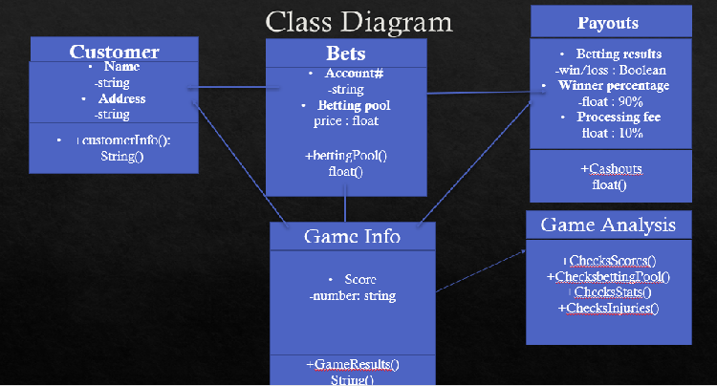

#### 3.3.1.1 Component Log-In of User Interface

A user will log in via the user interface. Upon logging in, the user will be redirected to the home page or the admin user home page. The admin users will have the options to add a user to the system, remove a user from the system, view the bets in progress, view the payout for a win based on odds of the bet, and keep a transaction history of clients. The homepage for users is a view of schedule and listings, placing bets, and viewing their own payouts. They will also have an option to contact an administrator regarding their payouts and transaction.

##### A screenshot of a map Description automatically generated3.3.1.1.1 Class Person of Component Log in of Database User Interface

# **Section 4.** User Interface Design

## 4.1 User Interface Design Overview

**Home Page**

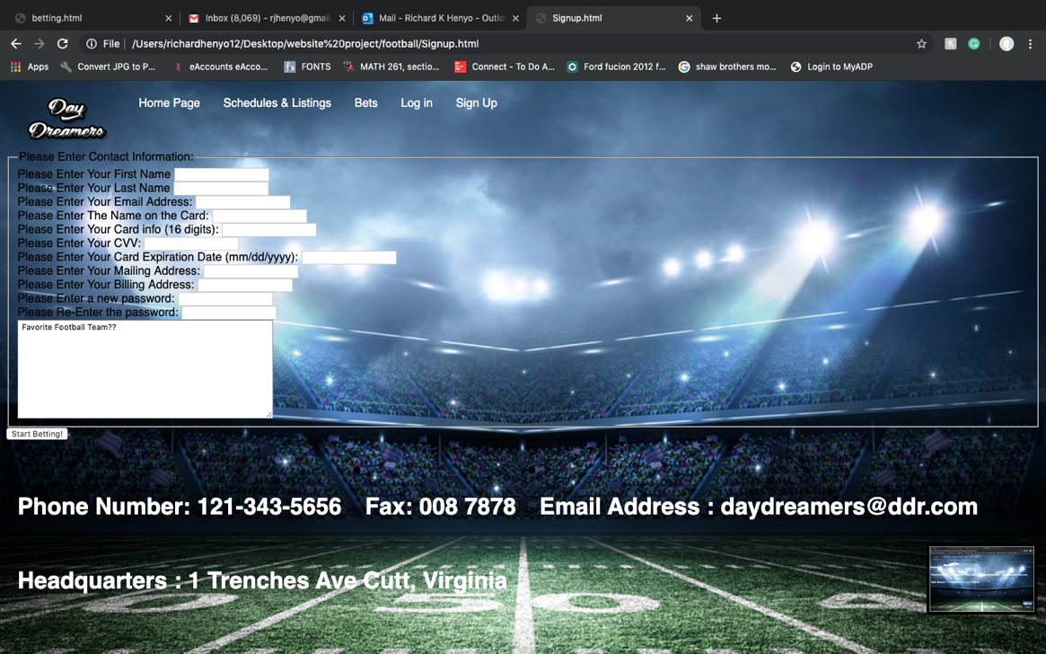**New User Sign Up Page**

**New Member log in**

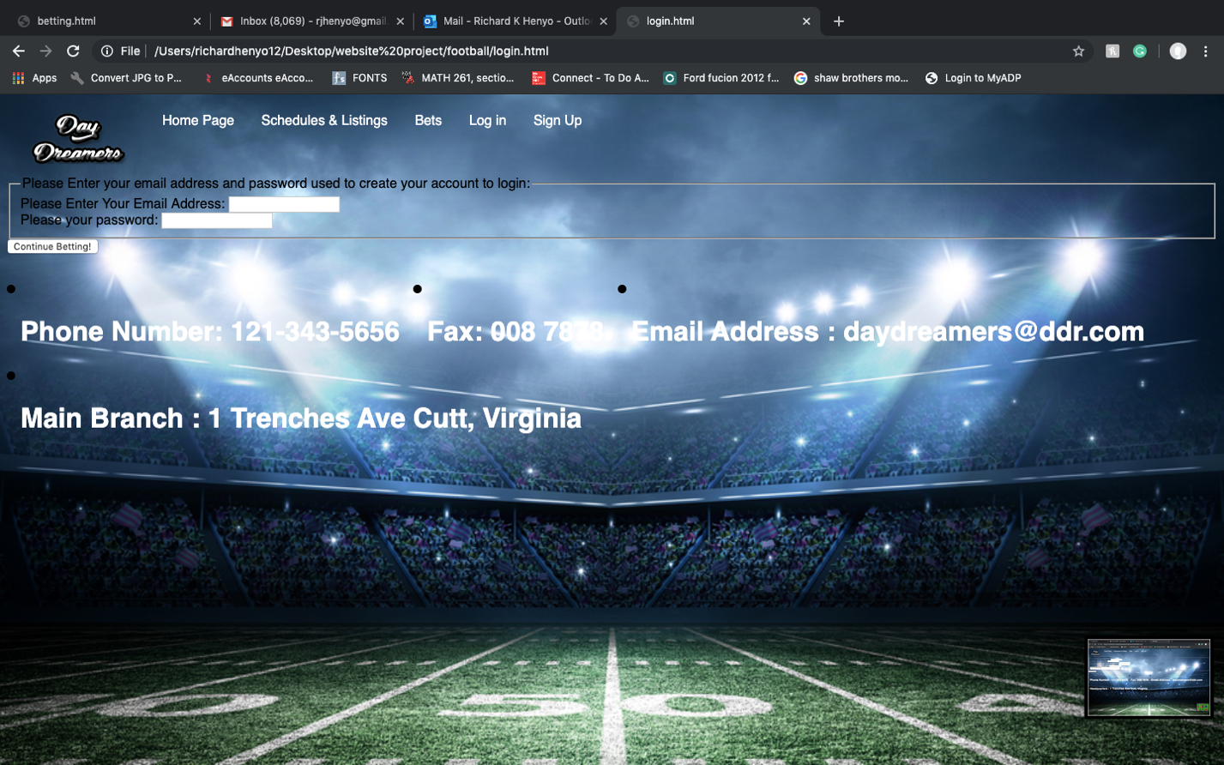

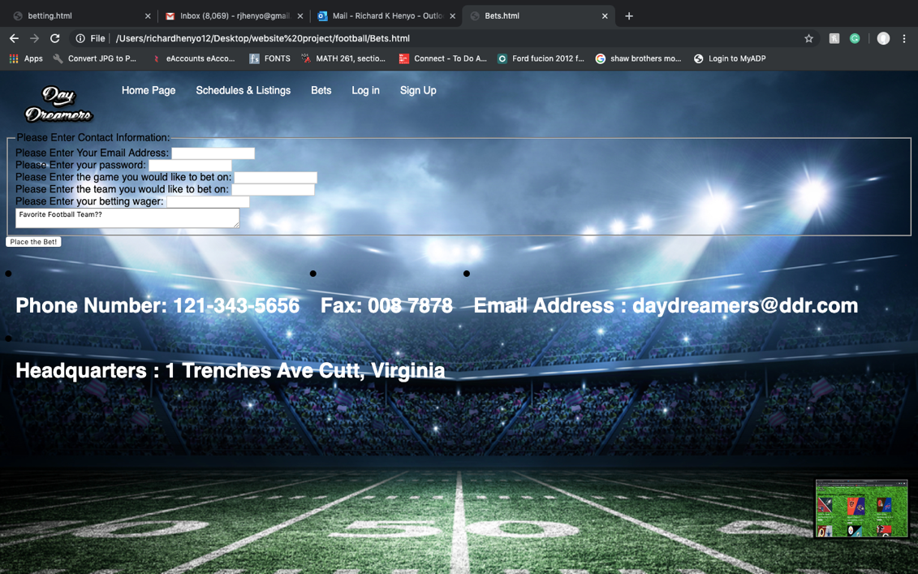**Betting Page**

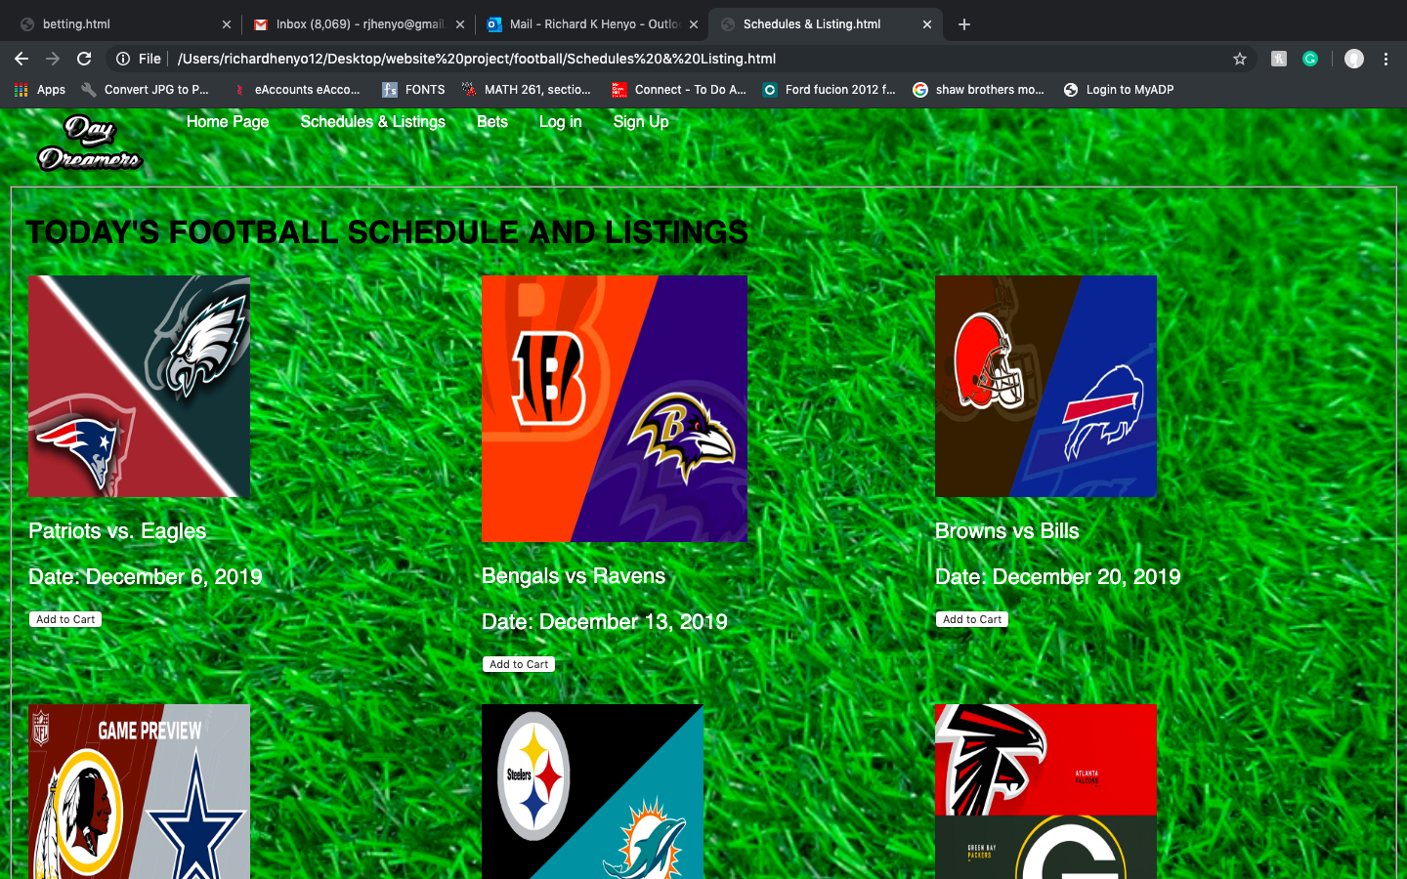**Schedule and Listings**

**Usability**

Student users will need to have a basic knowledge of internet usage and how to access betting sites. All users accessing the web interface will need to have basic knowledge of computers and the internet in order to access the website and effectively use its functions.

**Performance**

The performance of the system will depend upon the user’s internet connection and computer speed. The interface will be simplistic to make it easily accessible for users with slow connections.

**Interface**

The main interface for user interactions will be the web interface which allows students to view their attendance record and administrators to view attendance records, edit attendance records, edit student information, add a user, and delete a user.

## 

## 4.2 User Interface Navigation Hierarchy

## 

## When the user enters the web address in the address bar of their web browser they will be directed to the main log-in page. Upon arriving at the log-in page the user will be required to enter their username and password. When a student user logs in they will be directed to their homepage which displays their attendance record. They will then be able to log out or contact an administrator regarding their record. When an administrator logs in they will be directed to their homepage which has a menu of options. They will be able to view a student’s attendance record, edit an attendance

# **Section 11. References**

<https://github.com/ltmattocks/Betting-Pool>